Loading Instruction Set on to Flight Board EEPROM

**To Install the Lab Tools:**

This set of instructions requires the use of the Vivado Lab Tools software, version 2015.4. [This link](https://www.xilinx.com/support/download/index.html/content/xilinx/en/downloadNav/vivado-design-tools/archive.html) will take you to the Xilinx website and the archive of the Vivado software. This software is free, though it does require the user to register on the Xilinx.com website. See below for instructions on how to obtain the correct version of this software.

1. Click the link above to go to the Xilinx website
2. Select 2015.4 from the Archive Downloads list
3. Choose “Vivado Lab Edition – 2015.4 Full Product Installation” as the software to download
4. After clicking on the download (for Windows or Linux), the site will ask the user to log in. After doing so, information about the user is needed, enter it then press “Next” at the bottom. This will start the download.
5. A .tar.gz file will be downloaded. Unzip the file twice and a folder named “Xilinx_Vivado_Lab_Win_2015.4_1118_2” will be created.
6. Open the folder and run the executable “xsetup.exe”
7. Press continue when the installer prompts the user to get the latest version
8. Press next on the Welcome screen
   * You may have to log in using the credentials that were used to download the software, then press next
9. Click “I Agree” for each box then press next
10. Make sure that the following boxes are selected for your installation, then press next:

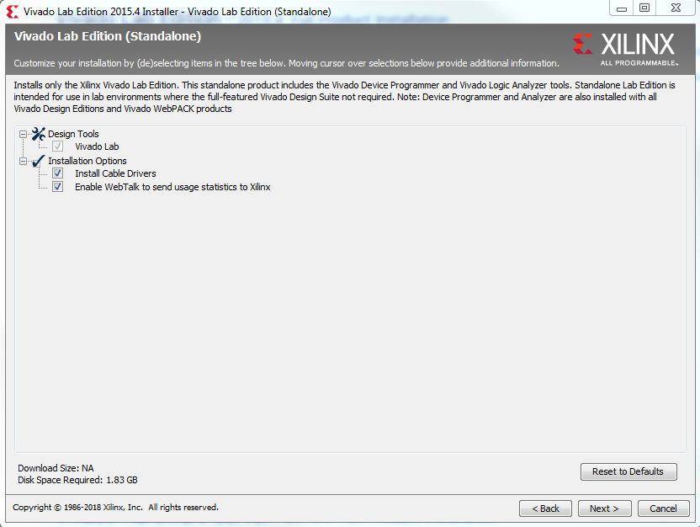

1. On the Select Destination Directory screen, make sure that the program will install in an appropriate location, then press next
2. The Installation summary will show the options which were selected, press Install. The install should take ~1-3 minutes
3. Near the end of the install, a box will pop up telling the user to disconnect all Xilinx cables. If you have a JTAG plugged in, unplug it from your computer.
4. When the install finishes, a box will pop up telling the user that the install completed successfully, press OK. The Lab Tools are now installed.

**Terminology:**

Lab Tools = Vivado Lab Tools Version 15.4

Flight board = …Circuit board which has the Zynq processor chip on it

Workspace = Local Directory consisting of the instructions for the FPGA and processor on the Zynq

Zynq = Xilinx System on a Chip. This is the name of a large family of chips, where we have utilized only the Z010 and Z020 chips.

FSBL = …………….First Stage Boot Loader

mcs file = ..………Boot file for the Flight Board, usually named BOOT.mcs

elf file = ………....Refers to the lunah_FSW_01_fsbl.elf file, the first stage boot loader for the Flight Board

JTAG = ……………JTAG programming cable

**To Program the Flight Board:**

1. Go to github ([link](https://github.com/RMDInc/LunaH_XC_FSW)) and download the project “LunaH_XC_FSW”.
2. Click “Clone or Download”

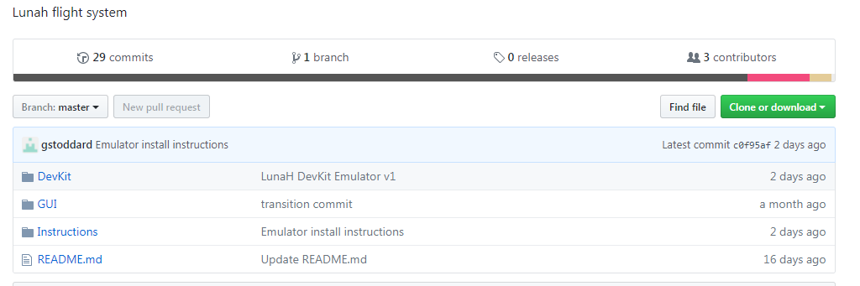

1. Unzip the data to a convenient and accessible location on your computer. The location of these files must be a file path with no spaces in it, otherwise the location is not important.
2. Start Lab Tools. The welcome screen will show.

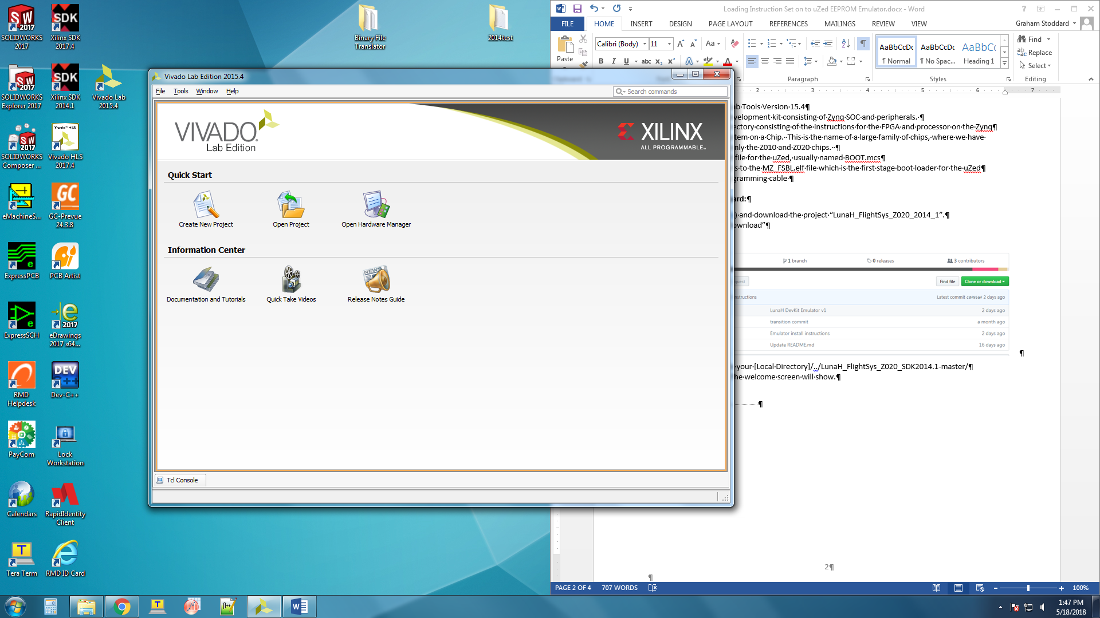

1. Connect the JTAG to the board and power it on. If the QSPI was previously programmed, then the green “Done” LED and the green “Power Good” LED will light up. If the QSPI is not programmed, then only the green “Power Good” LED will light up.
2. Going back to Lab Tools, click on “Open Hardware Manager”

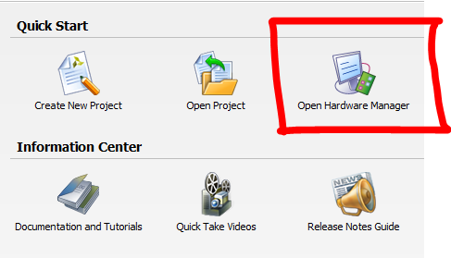

1. There will be a green banner at the top of the screen with the words “No hardware target is open. Open Target”. Click the words Open Target and then choose the Auto Connect option from the drop down menu.

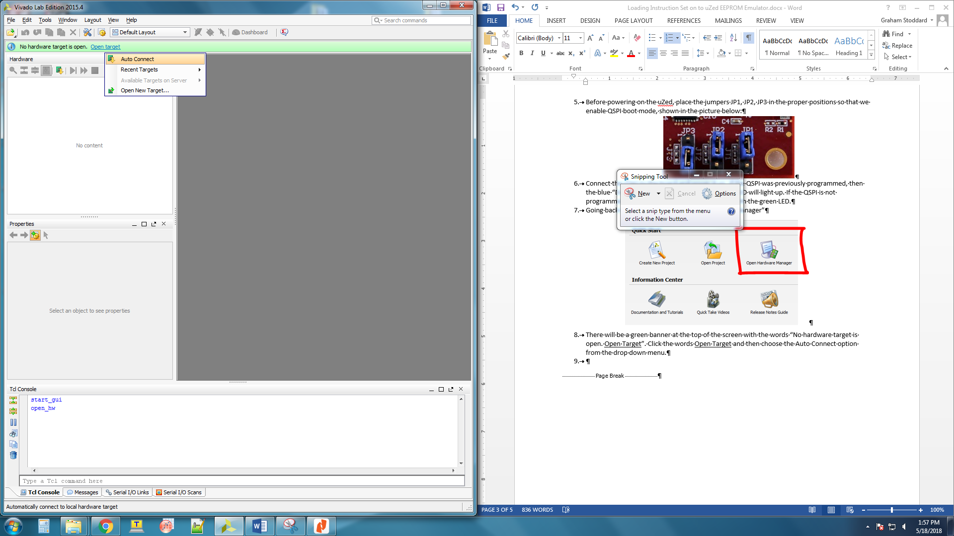

1. If the board is powered on, then Lab Tools will connect to it and display the board and chip information in the Hardware Window on the left side of the screen.

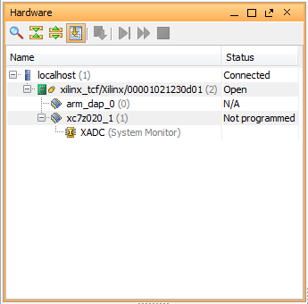

1. Click on “xc7z020_1” to select the Zynq chip and right click to open a drop down menu.
2. From the drop down, choose “Add Configuration Memory Device”, a window will pop up allowing us to choose from a variety of different memory devices.

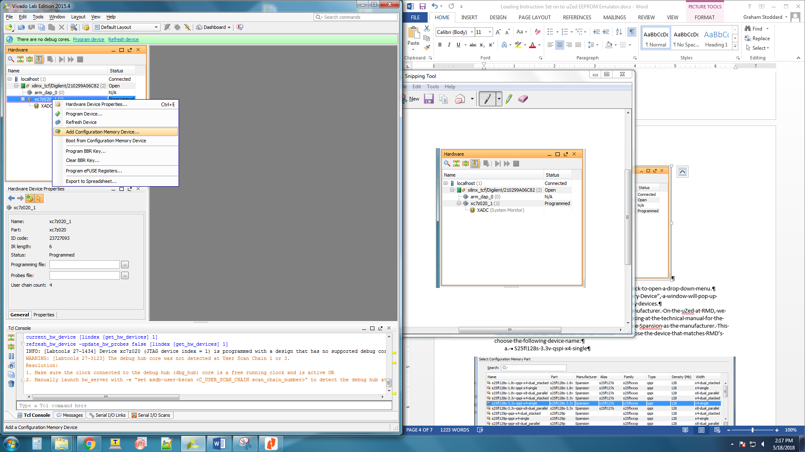

1. Under Filter, select from the drop down box labeled Manufacturer. On the Flight Board at RMD, we have the following QSPI: Macronix Mx25L25635f-qspi-x4-single and looking at the technical manual for the board, we find that it is powered with 3.3 V. Thus, choose Macronix as the manufacturer. This will refine the number of devices we can choose. To choose the device that matches RMD’s, select the above device name, then press OK.

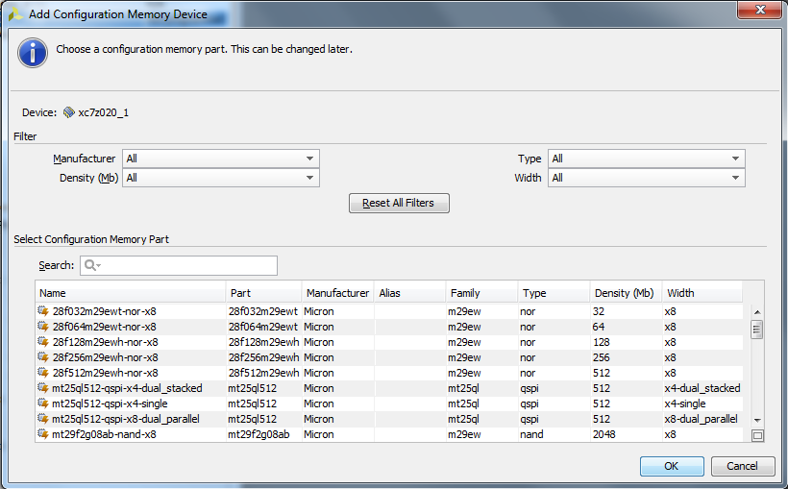

The Configuration Memory Devices Window

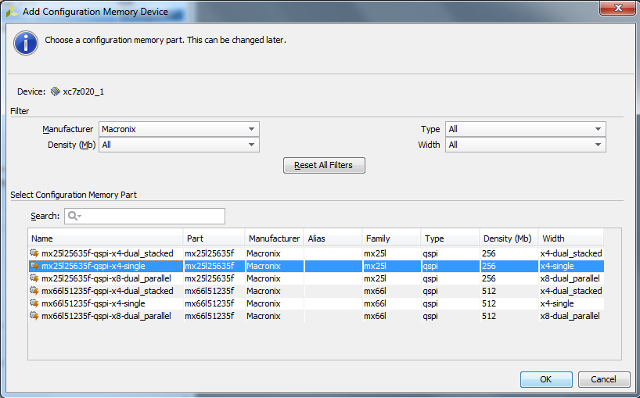

1. A window will pop up asking “Do you want to program the memory configuration device now?”, this means we will program the Boot files onto the board; click OK.
2. The “Program Configuration Memory Device” window will pop up, this is where we specify the boot files to be loaded onto the Flight Board. The memory device is pre-loaded into the form, but we must specify the Configuration File and the Zynq FSBL.
   1. For the configuration file, go to the files that were unzipped in step 3 and find BOOT.mcs
   2. For the Zynq FSBL, go to the files that were unzipped in step 3 and find lunah_FSW_01_fsbl.elf
3. The window should now be filled as shown in the following figure, assuming all the settings above were correct:

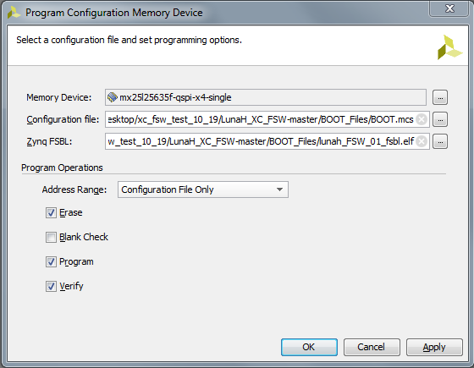

1. The final step is to decide what program operations we wish to perform; there is Erase, Blank Check, Program, and Verify. The standard procedure is to do Erase, Program, and Verify omitting Blank Check. The blank check operation determines if the memory device has been successfully erased by the Erase operation and is not critical for programming the Flight Board.
2. Press OK to begin the programming operations chosen. This will take a few minutes.
3. After the operations have finished, Lab Tools will pop up a small window informing the user that Flash programming was completed successfully, press ok. At this point, the green “Power Good” LED should be lit up. Power cycle the board and the green “Done” LED and the green “Power Good” LED should be lit up. This indicates success.